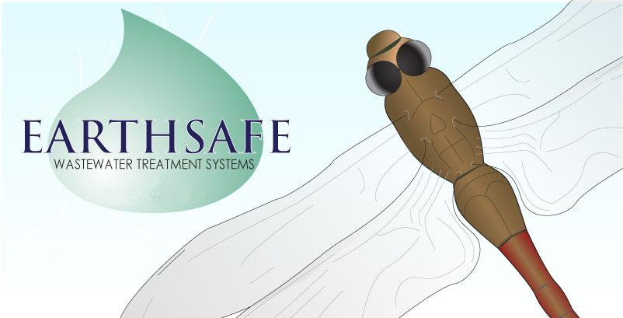
Eco Water Treatment
ABN: 64 143 207 658

9 Mackie Way, Brendale Qld 4500
PO Box 5981, Brendale Qld 4500

Ph: (07) 3205 3666
Fx: (07) 3205 7155

Commissioning Certificate
“EARTHSAFE” Wastewater Treatment System Only

CLIENT DETAILS

Name:
Site Address:
Postcode
Postal Address: (if different to above)
Postcode
Telephone: (Home) (Mobile)
Local Shire:

SYSTEM DETAILS
Type of Treatment System: Poly twin-tank
Concrete single tank
Riser Ring size (if applicable)
Air Blower Serial No
Irrigation Pump Serial No
Aggregate Filter Serial No
Irrigation Details

Installation and commissioning of the above has been completed to the satisfaction of the client, and in accordance with manufacturer and local Shire guidelines.

The system installed complies with the certificate of accreditation issued by all local government requirements.

Installation Date: Commission Date:
Installing Agent:
Agent’s Signature:

